# Acceptance Testing

|  |  |
| --- | --- |
| Group number | T12 |
| Name (printed) | | Signature |
| Samuel Thompson | |  |
| Joseph Torr | |  |
| Gary Tyre | |  |
| David Valente | |  |
|  | |  |

**Core Game**

|  |  |  |  |  |  |  |  |
| --- | --- | --- | --- | --- | --- | --- | --- |
| Test Case ID | Use case ref | **Description of Test** | **Test Initialisation** | **Test Inputs** | **Test Procedure** | **Expected Results** | **Passed?** |
| tG001 | ucG001 | **Paddle movement** | **In game** | **Mouse** | **Move the mouse** | **Paddle moves within bounds** |  |
| tG002 | ucG002 | **Paddle strike** | **In game** | **Mouse** | **Strike the puck with the paddle** | **Puck moves as if struck** |  |
| tG003 | ucG003 | **Puck movement** | **In game** | **Moving puck** | **Let puck slow down** | **Puck never completely stops moving** | N/A |
| tG004 | ucG004 | **Goal** | **In game** | **Puck in goal** | **Puck is in goal** | **Score routine.** |  |

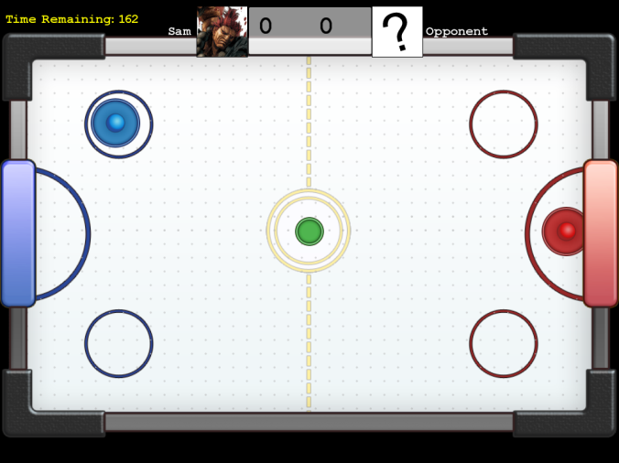

|  |  |  |  |  |  |  |  |
| --- | --- | --- | --- | --- | --- | --- | --- |
| tG001 | ucG01 | **Paddle movement** | **In game** | **Mouse** | **Move the mouse** | **Paddle moves within bounds** |  |

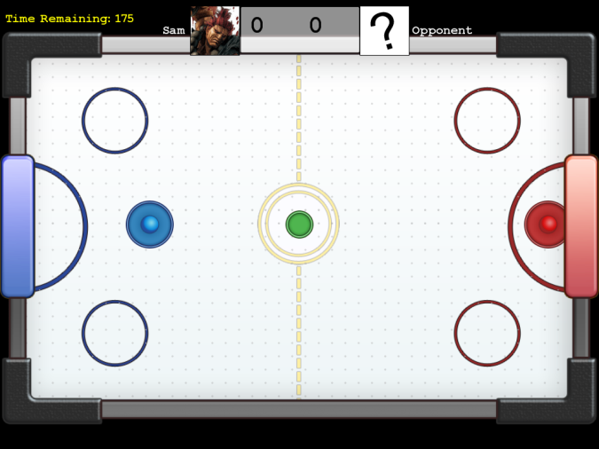

When the player moves their mouse, the blue puck is moved across the board.

|  |  |  |  |  |  |  |  |
| --- | --- | --- | --- | --- | --- | --- | --- |
| tG002 | ucG02 | **Paddle strike** | **In game** | **Mouse** | **Strike the puck with the paddle** | **Puck moves as if struck** |  |

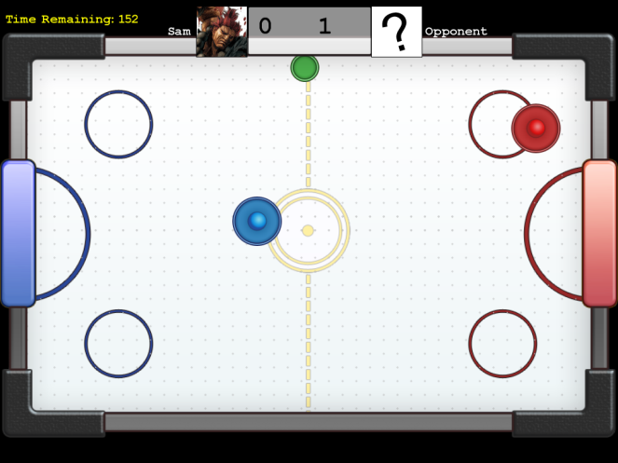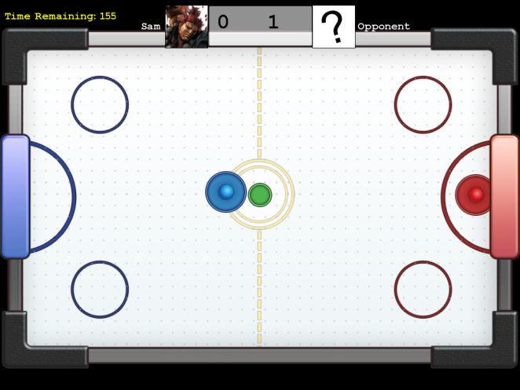

When the puck is struck by the paddle, it moves around the board.

|  |  |  |  |  |  |  |  |
| --- | --- | --- | --- | --- | --- | --- | --- |
| tG003 | ucG03 | **Puck movement** | **In game** | **Moving puck** | **Let puck slow down** | **Puck never completely stops moving** | N/A |

It was decided that this was not a desirable feature of the game as it took away from the game play once implemented. For that reason, this feature was dropped.

|  |  |  |  |  |  |  |  |
| --- | --- | --- | --- | --- | --- | --- | --- |
| tG004 | ucG004 | **Goal** | **In game** | **Puck in goal** | **Puck is in goal** | **Score routine.** |  |

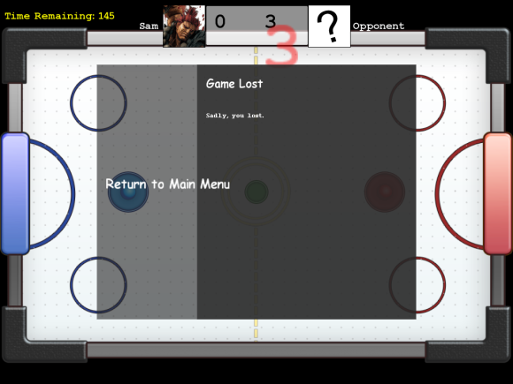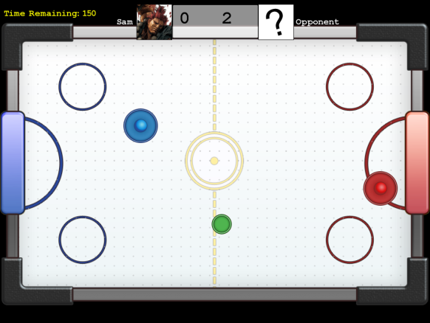

When the puck collides with a goal, the number in the score board increases and

**AI**

|  |  |  |  |  |  |  |  |
| --- | --- | --- | --- | --- | --- | --- | --- |
| Test Case ID | Use case ref | **Description of Test** | **Test Initialisation** | **Test Inputs** | **Test Procedure** | **Expected Results** | **Passed?** |
| tA001 | ucA001 | **AI seeking** | **In game** | **Mouse** | **Puck position** | **AI seeks puck** |  |
| tA002 | ucA002 | **AI strike** | **In game** | **Mouse** | **Puck position** | **AI strikes puck** |  |
| tA003 | ucA003 | **AI defend** | **In game** | **Moving puck** | **Puck position** | **AI will attempts to block goal** |  |

|  |  |  |  |  |  |  |  |
| --- | --- | --- | --- | --- | --- | --- | --- |
| tA001 | ucA001 | **AI seeking** | **In game** | **Mouse** | **Puck position** | **AI seeks puck** |  |

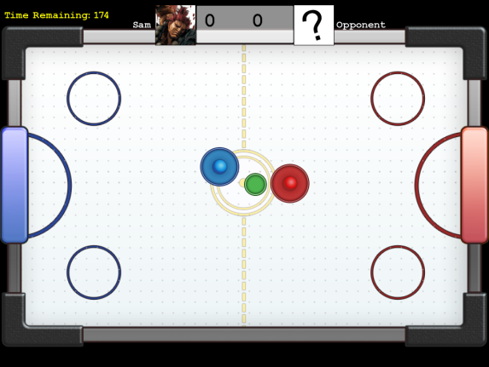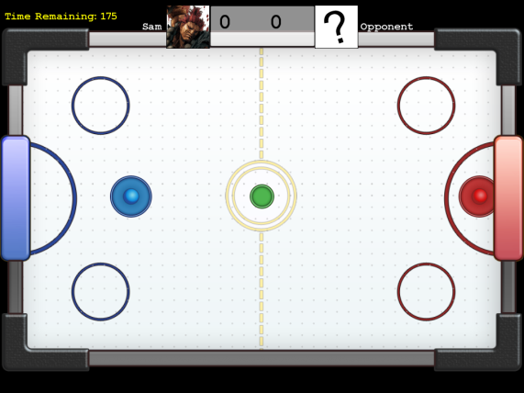

When the puck is in the AI’s half, the AI will move after the puck. The speed at which the AI does this is determined by the game difficulty settings

|  |  |  |  |  |  |  |  |
| --- | --- | --- | --- | --- | --- | --- | --- |
| tA002 | ucA002 | **AI strike** | **In game** | **Mouse** | **Puck position** | **AI strikes puck** |  |

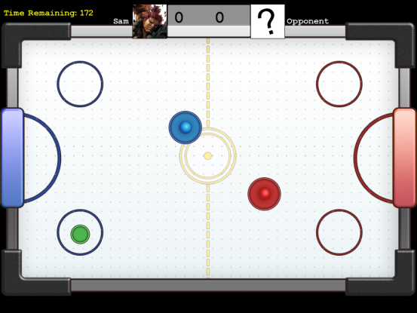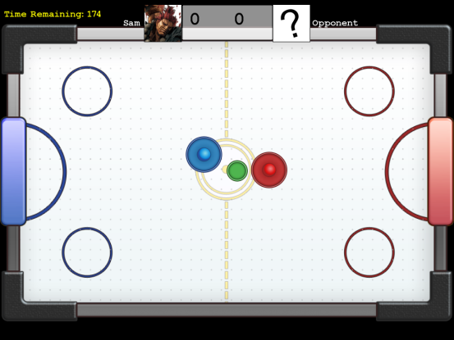

The AI will strike the puck with it’s paddle, sending it towards the opponent’s goal.

|  |  |  |  |  |  |  |  |
| --- | --- | --- | --- | --- | --- | --- | --- |
| tA003 | ucA003 | **AI defend** | **In game** | **Moving puck** | **Puck position** | **AI will attempts to block goal** |  |

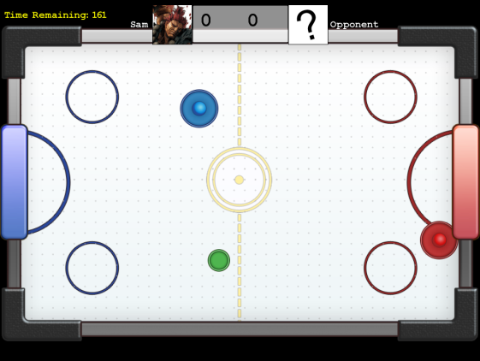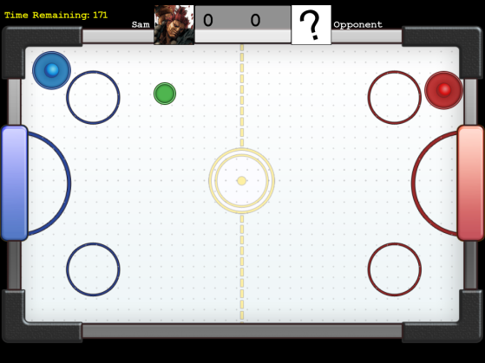

If the puck is in the player’s half, the AI will mimic it’s y position. As with all other AI actions, the competence of this action is determined by difficulty settings. If the puck moves back into the AI’s half again, it will go back on the offensive, or defensive if the puck is closer to it’s goal than it is.